When talking about a breed, dog fanciers usually have a purebred dog in mind, like a Border Terrier or an English Cocker Spaniel. However, most of our present purebred dogs share their history with other dogs of the same type. In the past, they belonged to a general group of dogs - like Terriers or Spaniels - with more or less the same characteristics. It was not until the 19th and early 20th centuries that people became interested in dogs as purebreds. The different types were separated
and named and their appearance was recorded in breed standards. Unfortunately, some types could not maintain themselves and disap- peared, either because their number was too small, or through human selection.
Vanished Dog Breeds (Part 1)

There are many examples of extinct breeds in the history of dogs
Tweed Spaniel Norfolk Spaniel English Water Spaniel
Text and illustrations: Ria Hörter

Founding Fathers
The disappearance of some members of a group with the same characteristics does not happen
overnight. If there is no human intervention this process happens gradually, but the day will eventually
come when the number of animals is not sufficient to keep going. There are many examples of vanished
or extinct breeds in the history of dogs. Some simply disappeared; others live on as the foundation of
one or more purebred dogs of today. Good examples are the Tweed Spaniel and the Norfolk Spaniel.
The Tweed Spaniel stood at the birth of the Golden Retriever and the Norfolk Spaniel is just an ‘early
edition’ of today’s English Springer Spaniel. The only spaniel that really has disappeared, apparently
without a trace, is the English Water Spaniel.

Tweed Spaniel
Ladykirk Spaniel
When you read about the origin and history of the Golden Retriever you can’t miss the Tweed (Water)
Spaniel. At the end of the 19th century, Sir Dudley Coutts Marjoribanks (1820-1894) was breeding
gundogs on the Scottish estate Guisachan in the county of Invernesshire. His main breed was the
‘yellow Retriever’. The colour is important because at that time, black Retrievers were generally known,
but the yellows of Sir Dudley were uncommon. In 1868 Sir Dudley - who had been awarded the title
Lord Tweedmouth in 1861 - bred a litter, using his yellow male ‘Nous’ on the bitch ‘Belle’. Four yellow
puppies were born, all of them bitches. In later years this litter became known world wide as the basis
of the Golden Retriever breed as we know it today.

“Spaniel in a landscape”, oil painting dating from 1777, by George Stubbs (1724-1806). This is an early depiction of a red-and-white, or brown-and-white or liver-and-white spaniel. It reminds one of the working English Springer Spaniel of today and it meets the description of J.R. Walsh: “a small, heavily built English Setter”. (Encore Editions.)

Coloured etching by Henry Thomas Alken Sr. “Three Water Spaniels”, dating from 1820. (Collection AKC Museum, Encore Editions.)
A “Brown and White Norfolk Spaniel”, painted by George Stubbs (1724-1806). (Encore Editions.)

The male ‘Nous’ may be of great importance for Golden Retriever fanciers, but we are more interested in the bitch ‘Belle’, a Ladykirk or Tweed Spaniel. (Ladykirk is a little town on the River Tweed.) The only thing we know about ‘Belle’ is that she had been given to Lord Tweedmouth as a present by a relative, David Robertson, a Member of Parliament. Apart from ‘Belle’, there was another Tweed Spaniel in his Lordship’s kennels (since 1863), named
‘Tweed’. This dog was never used for breeding, but evidence shows that he was succeeded by a namesake, who was mentioned in 1873. The second ‘Tweed’ was bred to a Retriever bitch, called ‘Cowslip’.
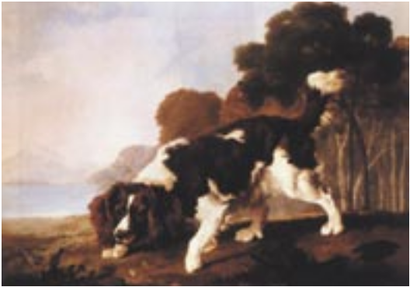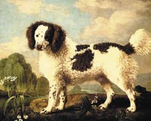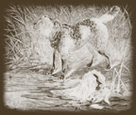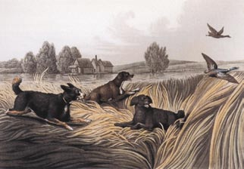

Old photograph of a Norfolk Spaniel. Heavily feathered ears and curly coats are in vogue
at the end of the 19th Century. (From: ‘Old working Dogs’ by David Hancock.)

Norfolk Spaniels. From Cassell, ‘The Book of the
Dog’ (1881).
From 1835 to 1890 Lord Tweedmouth kept a studbook in which he recorded not only the names of his dogs, but also their origins. There is another document, dating after 1884 and written in his Lordship’s own hand, in which Sir Dudley had noted down the litters of ‘Belle’ and ‘Tweed’.
“A small type of Retriever” – What did a Tweed Spaniel look like? More or less the same as the old English Water Spaniel depicted in paintings? Or was the Ladykirk or Tweed Spaniel a local variety of water spaniel? In spite of investigations I have not been able to trace a true depiction or a reliable eye witness. However, evidence shows that these spaniels lived almost exclusively in the border region between England and Scotland, the Tweed basin.
The coat of the Tweed Spaniel was liver coloured and curly, but ‘liver coloured’ should be interpreted widely. In those days “sandy”, “fawn” and “brownish” were also used to describe liver-coloured dogs. There is a print by John Carlton, showing a dog of a spaniel/retriever type, curly coated, long tailed and carrying a duck.
According to tradition, this engraving should be of a Tweed Spaniel. There is some resemblance to the Irish Water Spaniel. Both ‘Stonehenge’ in his book The Dog (1864) and H. de la Blanchère in Les Chiennes de Chasse (1875) described the Tweed Spaniel as “a small type of Retriever”. Others maintained that he was just a variety of the Irish Water Spaniel. A third version was that the Tweed Spaniel descended from Water Spaniels living along England’s east coast, in the area around Yarmouth. As for the relation with the Irish Water Spaniel: the Tweed Spaniel had a pointed skull and his muzzle was heavier.
Anyway, there was a reason to breed the Tweed Spaniel to Sir Dudley’s yellow Retrievers. The aim was to breed a dog that could find and retrieve game from great distances and out of water. The Tweed Spaniel and the yellow Retrievers were crossbred only two or three times. Historians agree that the Tweed Spaniel is now extinct.

Norfolk Spaniel (Shropshire Spaniel)
By the 16th Century, writers were distinguishing Land Spaniels from Water Spaniels. The name Springing Spaniel came into use in the 18th Century. “Springing” refers to the Spaniel’s job of springing (flushing) the game. The present Clumber Spaniel, English Cocker Spaniel, Field Spaniel, Sussex Spaniel and English Springer Spaniel are the descendants of the old Land Spaniels.
We do not know precisely why one of these Land Spaniels got the prefix ‘Norfolk’. Most dog book authors assume that Norfolk comes from the Duke of Norfolk, a Spaniel owner living in the County of Sussex around 1800. I have tried to find out which Duke of Norfolk is referred to, but unfortunately without any result. Is it the
8th Duke, the 9th, 10th or perhaps the 11th? The supposed connection between the Norfolk Spaniel and a Duke of Norfolk only dates from 1845, when William Youatt wrote about the Duke and his spaniels in The Dog. James Farrow, a well-known breeder 19th-century spaniel breeder, did not believe in a connection between the ducal family and the Norfolk Spaniels. He wrote a letter to the Duke, asking him if Youatt’s story was true.

Oil painting of Henry Bernard Chalon: “Quaille, an English Water Spaniel” (1797). (Richard Green Gallery, Encore Editions.)

a- '-'Tl Il \l>.\)11 t.L
...... ·- ........ '1.AJ""'
English Water Spaniels (about 1900). An engraving by Paul Mahler published in the
French magazine “L’Acclimatation”.

The result of his investigation was a letter from the Duke of Norfolk himself, in which he strongly denied any relation between his family name and the prefix of the Spaniel. “My grandfather, however, owned a group of Sussex Spaniels”, the Duke wrote to Farrow. In
1899 Farrow’s letter from the Duke was published in The Kennel Gazette. One would think that its publication would have dispelled the misunderstanding about the origin of the Norfolk’s Spaniel’s prefix.

‘Comforters’
In 1905, James Watson wrote in his The Dog Book that the ducal family of Norfolk indeed owned spaniels, but he described them as “Toy Black and Tan Spaniels”. Chances are great that Watson was writing about the miniature version of the Land Spaniels, called “Comforters”, small family dogs, very popular in the time of King Charles II. Today we know the small black-and-tan spaniel as the (Cavalier) King Charles Spaniel.
It is remarkable that the relation between the Duke of Norfolk and the Norfolk Spaniel persisted. Let’s forget about the Duke, because it’s far more plausible that the prefix came from the region where this type of spaniel lived and was frequently used for hunting. The
A Water Spaniel by George Stubbs (1724-
1806). (Encore Editions.)
Norfolk Spaniel is also called Shropshire Spaniel; this supports the theory about the county rather than the one about the
Duke.
To salve wounded feelings, however, there is another noble connection. It seems that King Edward VII, when still Prince of Wales, used Norfolk Spaniels when hunting in the fields of Sandringham Castle in the 1860’s. As we know, Sandringham Castle is situated in... the county of Norfolk.
Unlike other working Spaniels, it seems that the Norfolk Spaniel gave tongue when working and that he was not easy to train. What we do know for sure is how the Norfolk Spaniel looked. Thanks to old dog books we can determine that they belonged to the group of Spaniels measuring 17 to 18 inches. They were a bit high on leg, the ears were heavily feathered and the colour was liver-and-white or black-and-white. This description immediately reminds one of the present-day English Springer Spaniel.

Small, heavily built English Setter
In 1867 well-known dog-book author J.R. Walsh wrote in the magazine The Dog: “The Norfolk Spaniel resembles a thickly made English Setter in shape and general proportions, but is a smaller size. This is a very useful breed, and is now generally spread throughout England, where, however, it is not kept very pure.” In 1872 his colleague Thomas Pearce (‘Idstone’) wrote: “Almost any liver-coloured-and white moderately large dog is called a Norfolk, more Norfolk Spaniels being used than any other.” He continued: “Most gamekeepers keep a liver and white one, and it goes by the name of the Norfolk dog.” Rawdon B. Lee wrote in Modern Sporting Dogs, in 1893, that as far as he was concerned the Norfolk Spaniel was just a cross between a curly-coated water spaniel and a Sussex Spaniel or another breed. The liver-and-white spaniels were seen everywhere, he stated. In 1880 Vero Shaw wrote: “The last variety of the Springer family which we shall treat is the Norfolk Spaniel... this dog is, when found pure, most usually a liver-and-white, the white spots being heavily flecked with liver... A blaze of white up the

‘Dash II’, a Norfolk Spaniel exported to the United States of
America.

English Water Spaniel
forehead adds a great deal to his beauty.” From the various descriptions we have a splendid picture of the Norfolk Spaniel: a small, heavily built English Setter, quite high on leg, liver-and-white, a spot on the forehead, heavily feathered ears and with many freckles.

‘Dash II’
The Norfolk Spaniel is considered an ancestor, or early edition, of the English Springer Spaniel. In 1857, the
Norfolk Spaniel was exhibited under the name “Norfolk Spaniel or Springer”. We know that for sure because
‘Tissington Flush’ was involved, owned by Sir Hugo Fitz-Herbert. She is the same bitch as painted by the famous
Maud Earl. Even in the United States the Norfolk was known. In 1886, a certain ‘Dash II’, bred by E.M. Oldham
of England, appeared at the dog show in Madison Garden in New York. He won first prize in “a class for larger
spaniels”. His photograph shows him to be a low-legged Spaniel, broad in skull and with a short neck - not exactly
a beauty.
In 1885, the Sporting Spaniel Club was founded in England and from that time, the name Norfolk Spaniel lost ground. The prefix Norfolk did not survive the classification of spaniels in 1902.
What remains are the painting of Maud Earl and the lovely engraving in Cassell’s The Book of the Dog’ (1881), showing two Norfolk Spaniels. One retrieves the game, the other - not docked - is watching on the waterfront.
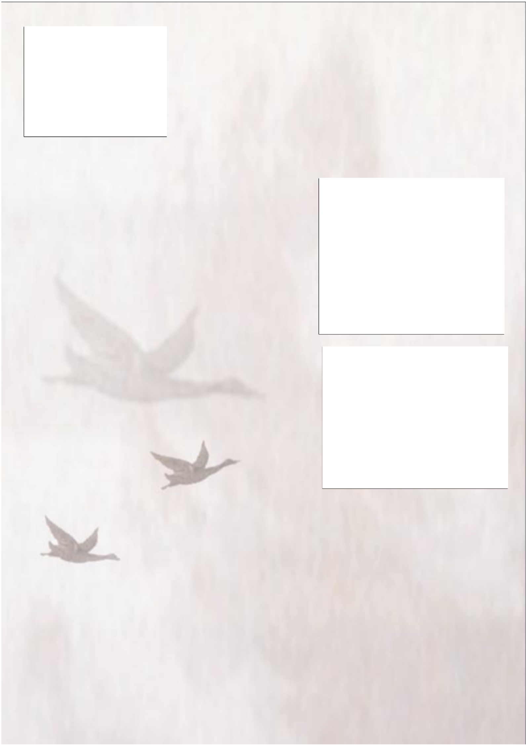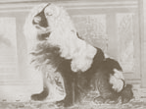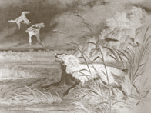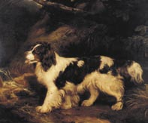A standard work, published in 1607, mentioned the “Water Spagnel”, and every author of dog books dating from the 18th and 19th centuries described the water spaniels or water dogs. Very rarely do their descriptions fit the appearance of the present Irish Water Spaniel. It seems that these water spaniels had very little or nothing to do with the Irish. If you put together the characteristics, they resembled the present Welsh Springer Spaniel, but with a wavy or curly coat and a pointed muzzle.
In the 1850’s ‘Stonehenge’ (J.R. Walsh) wrote about spaniels in general in his book Manual of British Rural Sports. His definition of a spaniel was quite simple: dogs that find the game and leave the killing of it to their masters. Like many authors before and after him, Walsh divided the spaniels into Land Spaniels and Water Spaniels. In his opinion, the water spaniels could be divided into two varieties: the Irish Water Spaniel and the now-extinct English Water Spaniel. I deliberately use the word “extinct” and not “vanished”, because the English Water Spaniel has not left traceable tracks. In the first half of the 18th century, this spaniel was used in the county of East Anglia for duck hunting. “After two centuries of breeding it is now extinct”, John F. Gordon wrote in 1967. “None has been seen for over thirty years.”

Curly coat
A description of the English Water Spaniel is given by Edward Ash in Dogs, Their History and Development, published in 1927. He would have looked more or less like a Collie, probably a cross between a rough-haired water dog or poodle and the springer spaniel or setter. Just go ahead and try picturing that! The influence of springer spaniels on these crossbred dogs was the reason they resembled a spaniel, but with the typical curly coat of a water dog. The height of the English Water Spaniel was approximately 20 inches and the colours of its coat were liver or tan and white. We should give a wide interpretation to “liver”, because the English Water Spaniel is also depicted as brown and white, and orange and white.

Hunting ducks
Both Henri Bernard Chalon and Richard Ramsay Reinagle left us beautiful paintings of the English Water Spaniel. I think we can assume that Reinagle in particular has given a true representation of the English Water Spaniel, because his painting matches the written descriptions. Reinagle’s Water Spaniel does not resemble the Collie. The engraving by Henry Thomas Alken Sr. shows a different type of Water Spaniel. But they have curly coats and Alken has depicted these spaniels doing their most important work: hunting ducks.
Finally we can find a very clear description of the English Water Spaniel in The Sportman’s Repository (1820). If you want to hunt ducks or other waterfowl, you had better use an English Water Spaniel, the author advises. It has a curly coat like a Poodle, and swims and dives as well as the ducks. This dog will not be tempted when the ducks try to lure him and his master on the wrong track, far away from the nesting places. The author of this article knew exactly what the dog looked like: he resembled the Land Spaniel, but was higher on leg and not as heavy. The best ones were the dogs with long ears whose coat was white under the belly and around the neck, but brown on the back.

All disappeared
Today they have all disappeared: the “small retriever”, the “small heavily built English Setter” and the “spaniel that supposedly looked like a Collie”. They nevertheless played an important role in yesterday’s dog world. They have vanished, but are not lost, because according to the British dog historian David Hancock, we can see their heritage in the modern Golden Retriever, Flatcoated Retriever, Chesapeake Bay Retriever, Curly Coated Retriever and, of course, in the English Springer Spaniel.

A retired bookseller and publisher Ria Hörter, The Netherlands, is a writer of dog articles for “Onze Hond” and “Dogs in Canada”. She is also the President of the Dutch breed club for Welsh Springer Spaniels and the Secretary of the Dutch Gundog Association.
More information on her website www.riahorter.com

“Water Spaniel”, a painting by Richard Ramsey Reinagle, dating from 1815. (Collec- tion: Mrs. Walter M. Jeffords. Courtesy William Secord Gallery Inc., N.Y.)

“Water Spaniel”, engraving in ‘The Sportman’s Cabinet’ (1803). Note the thick curly coat, the heavily feathered ears and the undocked tail. The hunter who has shot the duck can be seen at the right.

Literature:
Alofs e.a., F.A.J., Jachtspaniels, 1973
Bishop, Gerald, Spaniels. Newton Abbot, 1984
Gordon, John F., The Spaniel Owner’s Encyclopaedia. London,
1979
Hancock, David, Old Working Dogs. Princes Risborough, 1998
Hutchinson, Walter, Hutchinson’s Popular Illustrated Dog
Encyclopaedia. London, 1927
Ilchester, Duke of, De oorsprong van de Gele Retriever, 1952
Lee, Rawdon B., Modern Sporting Dogs, London, 1893
Morland Hooper, Dorothy, The Springer Spaniel. London, 1972
Muirhead, Colin, The Complete English Springer Spaniel. Lydney,
1996
Ritchie, Carson I.A., The British Dog, Its History from Earliest
Times. London, 1981
Seegers, L., Hondenrassen, hun oorsprong, hunne geschiedenis en
hunne ontwikkeling in Nederland. Amsterdam, 1912 and 1914
Strebel, Richard, Die Deutschen Hunde. Mürlenbach, 1986.
Reprint 1904/05
Waters, Nick, A Bundle of Rags in a Cyclone. Shrewsbury, 1998
Watson, James, The Dog Book. New York, 1905
Various websites

